MERCIA ARCHERS 50/50 ENTRY FORM

Sunday 31st August 2025

Registration from 10.00am
Sighters 11.00am

Forename | Surname | Gender | Club |  | AGB No. | Senior | Junior | Bow Type  LB/RC/BB/C | Fee | Consent to store details  Y/N | Parent signature for Juniors
 |  |  |  |  |  |  | 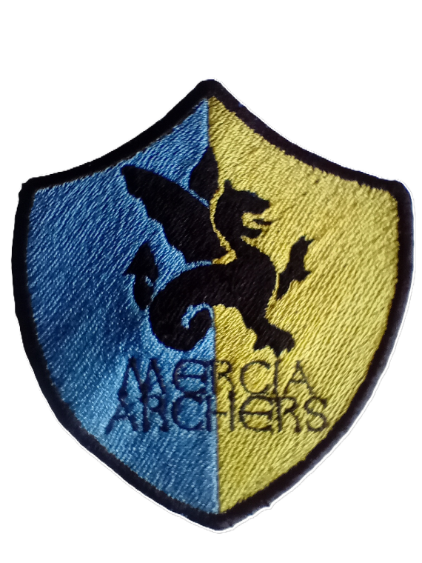
Contact Name : |  |  |  | Contact Tel Number |  |  |  |  | Contact Email Address:

Fees: Seniors £10.00, Juniors £5.00
Please email the completed entry form to jamesonderek17@gmail.com and make payment by BACS to
Mercia Archers, sort code 20-84-13 account number 93703924

Closing Date: August 24th 2025 or when full

When you enter competitions the following information may be collected and shared with tournament organisers, scoring systems and other competitors: First Name, Surname, Gender, Bow style, Email, address, Phone number, Club. Results may also be published.

Please inform us of any access requirements.

